1. Characterizing Myself  - Use the character traits paper to find 2 traits that describe you.  - You should include:  evidence and an explanation (prove it!)  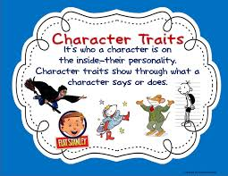 | 4. Comparing Texts  - Read the related reading passage. It is titled, “Who’s the New Kid?”  - Compare “Eleven” and “Who’s the New Kid?”  - Answer the comprehension questions in complete sentences.  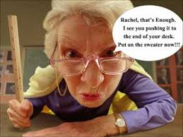  http://i1.ytimg.com/vi/XNLORtRI1FE/hqdefault.jpg
2.Inferring: Character Traits  - After reading “Eleven” by Sandra Cisneros, fill in the graphic organizer below.  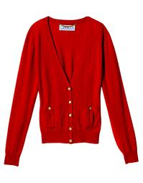  01eb9aeb20a910fda4031a9db57671e30b/redsweater-jpg.jpg | 3. Paragraph Writing (A.C.E.)  Choose one trait from either Rachel or Mrs. Price and explain how that trait affects the resolution of the story. How would the story’s resolution be different if Rachel or Mrs. Price did not exhibit that trait?
Inferring: Character Traits
Infer: Which character traits best describe Rachel?

Find four pieces of evidence from the story that support your inference.
Quote from text | Explanation (complete sentence that describes  how that quote supports your inference)
1.

2.

3.

4.

What point of view is this story written in? How does the author use this point of view to make the story more effective?

Which character trait best describes Mrs. Price? Use evidence from the text to support your answer.

Connect to Schema: Think about a time when you felt ___________________ like Rachel.
Describe your thoughts, words, or actions during that time.

Comparing Texts

What are some similarities and differences between “Who’s the New Kid” and “Eleven”? Fill in the chart below, writing in complete sentences.

Similarities | Differences

One critic has said that Sandra Cisneros (the author of “Eleven”), “makes the invisible, visible” How does Cisneros make Rachel’s feelings “visible” to readers?

Do you think Lois Lowry’s short memoir does the same thing that the critic described above? Why or why not?

Think about how both Rachel and Lois described their feelings in these two pieces. Do you feel the same way about yourself at age 11? Why or why not?

